PROJECT 1: PRELIMINARY ANALYSIS

Homework Manager

# TARGET USER

The target user for this project is a Computer Science student at BYU-Idaho. He is very busy, slightly forgetful, and has difficulty keeping track of all of his school assignments across multiple I-Learn platforms.

# INTERFACE

The interface this project will analyze is actually comprised of two different systems, namely, I-Learn 2.0 and I-Learn 3.0’s homework management interfaces. *By homework management, I mean keeping track of which assignments are due soon, and which assignments have been completed*. This interface is important to the target user because he has to use it daily, and his successful graduation depends upon him being able to manage his homework well. The pain point of this interface is that information that should be presented together is spread across multiple pages, making it difficult to manage (See figure 1.)

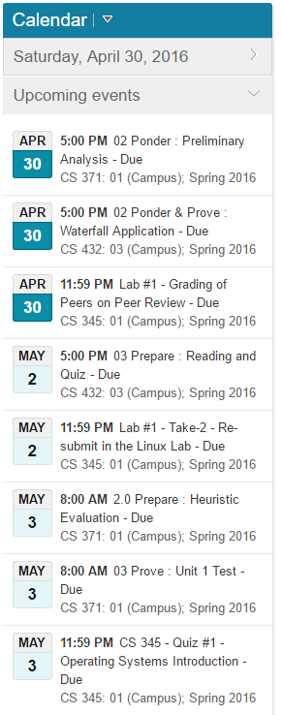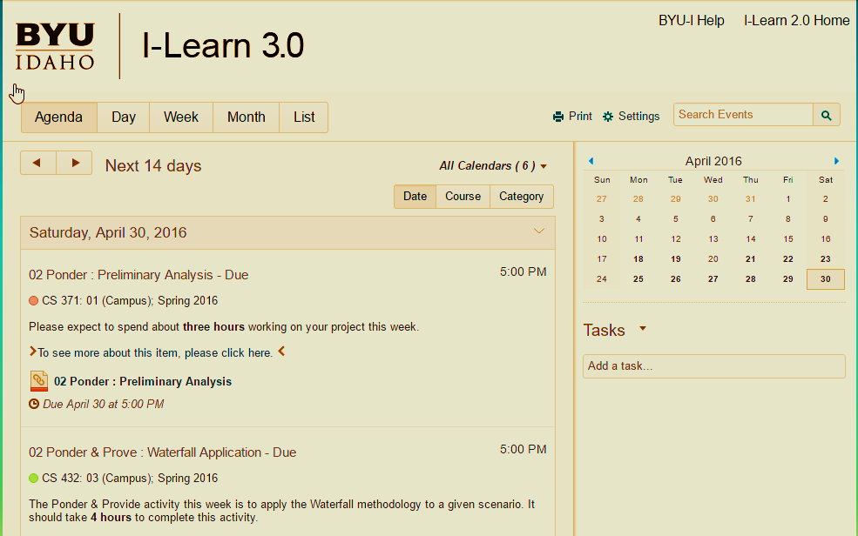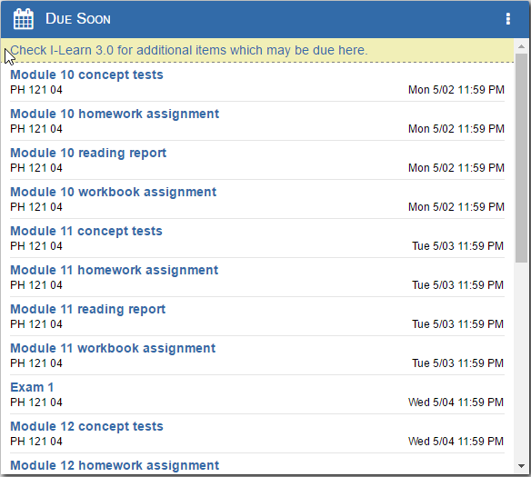

**Figure 1**. I-Learn 2.0 and I-Learn 3.0's Homework Management Interface

# INTERACTION FRAMEWORK

## Presentation

**MAIN PROBLEM** – The primary difficulty with this interface is that the data about a student’s homework is divided between two systems. This problem is complicated by I-Learn 3.0, as it does not visually differentiate between events in the queue that have been completed and those that haven’t. This information is in the system, but not presented to the user. (I-Learn 2.0 handles this by removing completed items from the queue.) This problem makes quickly managing your homework difficult because if you want to be sure that you’ve completed an assignment you need to follow the unintuitive process described in the specify sequence.

## Perception

Perception is not the problem. The user can see the available information just fine.

## Interpretation

Interpretation is not the problem, the available information is easy to understand

## Evaluation

While there may be a minor problem with evaluation (the system not conforming to the user’s belief in how things should work: due to I-Learn 2.0, users are trained to expect completed homework items to be removed from the queue), I don’t think this is a significant problem.

## Goal

The user wants to manage their homework. This is not a problem

## Intention

The user wants to manage their homework using the schools class management system. This is not a problem.

## Specify Sequence

**SECONDARY PROBLEM** - As described in the presentation section, if a user wishes to verify their submission of homework from the I-Learn 3.0 home page they must follow an unintuitive process. Instead of clicking on an item in the queue to see if it is complete, (this path eventually leads to the submission page which does not inform the user about prior submissions) you need to:

1. Select the class the assignment is from
2. Select the content page
3. Select the week or unit from the left side of the screen
4. View your assignment on the right side of the screen.

Ideally you’d be done here, but the checkmark to the right of the assignment doesn’t always signify completion, it sometimes only signifies that you’ve clicked the link before, so there is the additional step of clicking on the title of the assignment (not “the to see more link”). Finally, you are able to verify that you have submitted a file. If the user has learned how to do this, that is four clicks of the mouse for information that should be easily visible from the landing page. For new users, figuring out this unintuitive process takes many more clicks.

## Execute Sequence

Executing the steps, while tedious, is physically difficult. This is not a problem.

# VARIABLES OF USABILITY

## Efficiency: **-2**

The time required for a user to manage their homework is too high. This would be true for I-Learn 3.0 alone, as it requires many clicks to accomplish almost any task, but it is made worse by the fact that the user needs to navigate to at least two different systems to manage their homework (or more if they have a class from a teacher that doesn’t use I-Learn at all, like Brother Neff.) This is a -2, as moving between multiple systems is very inefficient compared to any comparable system that allows a user to manage their homework in one place.

## Learnability: **1**

Learnability isn’t a problem. The system is not complex, and the inductive leaps required to use I-Learn 2.0 and I-Learn 3.0 to manage their homework are not large.

## Familiarity: **-1**

Familiarity is a bit of a problem, as users are unfamiliar with I-Learn 3.0, and the way it manages homework is different enough from I-Learn 2.0 that it breaks the compatibility principle of familiarity.

## Simplicity: **0**

The mental models of the systems in this interface are relatively simple.

## Mapping: **-1**

It is difficult to manage a consistent mental model when switching between the systems of this interface. While each system may be internally consistent, merging multiple models creates conflict.

## Motivation: **-2**

The dominant emotional response of most users to this interface is irritation, impatience, or worse. Provided any viable alternative, many users would use the alternative. Users get frustrated with the number of clicks it takes to do anything, the poor visibility of needed information, and by being forced to use multiple systems.

## Trust: **0**

The feedback, fault tolerance, and controllability of this system are acceptable. The user can use the program without fear of losing work or data. The feedback provided to user actions works as expected.

## Visibility: **-2**

As a homework manager, this interface’s visibility is terrible. The user is forced to move between systems, and the I-Learn 3.0 portion interface is scores poorly on visibility even when considered alone. The user needs to know what homework is coming up, and what has already been done, and the ability to determine that information is not easily available.

# RUBRIC

